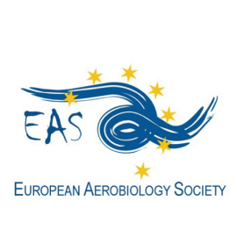<http://www.eas-aerobiology.eu/>

**GRANT APPLICATION FORM for**

[**BA 2022 – Basic Aerobiology Course**](https://adopt-bioaerosol.eu/ba-2022-basic-aerobiology-courseaerobiological-observations-molecular-immunological-and-cellularmethodsoctober-2022-evora-portugal/)

**Aerobiological observations: Molecular, immunological and cellular methods**

**Évora (Portugal), October 2022**

**EAS offers one grant to a young researcher (BSc, MSc or PhD student) covering the registration fee or travel and hotel expenses (up to 450 €) of the BA 2022 in Évora (Portugal).**

**Fill in this form and send it by 26th September 2022, together with the complementary documents, to the EAS General Secretary Thanos Damialis** [dthanos@bio.auth.gr](mailto:dthanos@bio.auth.gr)**, using the email Subject: EAS BA 2022 Grant Application_last name (i.e. EAS BA 2022 Grant Application_Damialis).**

Family Name: __________________________________First Name: _______________________________

E-mail: ______________________________________________________________________________________

Position (BSc, MSc, PhD Student): ________________________________________________

Date of birth: _______________________________________________________________________________

Institution/Organization: _________________________________________________________________

_______________________________________________________________________________________________

Prerequisites/Documents to be attached to the application form:

1. Motivation letter (not exceeding one page)
2. Short CV (not exceeding one page)
3. Support letter of the Home University
4. Confirmation that the student is an EAS member (prerequisite to apply for the grant): for non-members of EAS, please first register as members (<http://www.eas-aerobiology.eu/membership-and-membership-fees/>)

Other information of interest:

* A selection committee, consisting of EAS committee members, will make the selection of the candidates.
* The grant holder will be announced by the 30th September 2022.

IMPORTANT: By submitting this application it is hereby confirmed that no other financial support has been obtained by other sources, including the COST Action ADOPT.