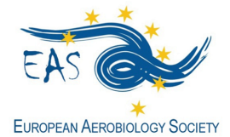
http://www.eas-aerobiology.eu/

GRANT APPLICATION FORM for
Basic Course on Aerobiology
Brussels (Belgium), 5 - 9 July 2021

EAS offers three grants covering the inscription to this Basic Course on Aerobiology for young researchers.

Fill in this form and send it by 28th February 2021, together with the complementary documents, to the EAS General Secretary Thanos Damialis dthanos@bio.auth.gr, using the email Subject: EAS BC Grant Application_last name (i.e. EAS BC Grant Application_Damialis).

Family Name: ______________________________ First Name: _______________________________
E-mail: ______________________________________________________________________________________
Position (Master Student, PhD Student, Other): _________________________________________
Date of birth: _______________________________________________________________________________
Institution/Organization: _________________________________________________________________
_______________________________________________________________________________________________
_______________________________________________________________________________________________
Are you member of:
- EAS ___________ (obliged to apply for the grant)
- IAA (International Association for Aerobiology) ____________ (not obliged to apply for the grant)
Documents to be included in the application form:
- Motivation letter (not exceeding one page)
- Short CV (not exceeding one page)
- Support letter from an EAS member (having payed 2021-2022 fees)

Other information of interest:
- A selection committee, consisting of EAS committee members, will make the selection of the candidates.
- The grant holders will be announced, the latest, by the end of March 2021, before the final registration and payment date.

