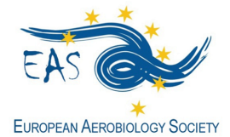
http://www.eas-aerobiology.eu/

GRANT APPLICATION FORM for
Basic Course on Aerobiology, Lyon (France), 15-20 July 2019

EAS offers two grants covering the inscription to this Basic Course on Aerobiology.

Fill in this form and send it by 31st March 2019, together with the complementary documents, to the EAS General Secretary Dr. Letty de Weger L.A.de_Weger@lumc.nl, using the email Subject: EAS BC Grant Application_last name (i.e. EAS BC Grant Application_de Weger).

Family Name: ______________________________ First Name: _______________________________
E-mail: ______________________________________________________________________________________
Position (Master Student, PhD Student, Other): _________________________________________
Institution/Organization: _________________________________________________________________
_______________________________________________________________________________________________
_______________________________________________________________________________________________
Are you member of:
- EAS ___________ (obliged to apply for the grant)
- IAA (International Association of Aerobiology) ____________ (not obliged to apply for the grant)
Documents to be included in the application form:
- Motivation letter (not exceeding one page)
- Short CV (not exceeding one page)
- Support letter from an EAS member (having payed 2019-2020 fees)

Other information of interest:
- A selection committee, consisting of EAS committee members, will make the selection of the candidates.
- The grant holder will be announced, the latest, by the end of April 2019.

